UFCFY3-15-3 Bio-Computation Assignment

Tsuo-Chia,Yang - 15023619

1 INTRODUCTION
Genetic algorithm (GA) is a research algorithm use to find the optimize result from large among of data sets. It belongs to the Evolutionary algorithm (EA). GA is a robust tool using Darwin’s concept “Survival of the fittest”, by using selection, crossover and mutation.

This paper is aiming to solve the set of classification problems by using GA. The algorithm is written to test 3 different data sets. In each test contains the condition on the left, and the output on the right. Data set 1 and 2 is made by binary numbers and data set 3 is made by floating point.

2 BACKGROUND RESEARCH
Data mining, a process uses for discover data from large data set. The aiming for the data mining is not just use to get the best fit of a big data set, also use to generate the new data. There are many data mining problems in life that need to be solved in optimized way. Under this background, multiple evolutionary algorithms are getting more and more use in the data mining (Anirban, Ujjwal, Sanghamitra, Carlos 2013).

The because of the multiple tasks Data mining have, classification, regression, modelling and so on. First step of this is design an algorithms base on different task. The task of classification for data mining is often follow the IF-THEN rule.

IF<conditions>THEN<output>

Rule antecedent (If part) holds the conditions, it is usually link with the logical operation (AND/OR). The rule consequent (Then part) holds the output, so after the rule antecedent, this will be the output. (Parpinelli, Lopes, Freitas 2002).

One of the evolutionary algorithms is Genetic Algorithm (GA). GA is a powerful tool to solve the data mining problem, with its robust search techniques. Although GA are using the random set, the search method it uses is direct, it is based on the natural selection, genetic recombination and biological evolution, other way to describe this algorithm is “survival of the fittest”. A study from last decade (Srinivasa, Venugopal and Patnaik 2007) talk about the self-adaptive migration model genetic algorithm for data mining. The migration model of GA can evolve a set of populations by parallel system, instead of one. In this method, all the populations in each generation are evolved independently. And after a regular migration rate, few of the best individuals will be select to replace the old population. So, the search will more and more closer to its goal.

From other paper (Hsu, Lai, Chiu 2003) it clearly shows the GA is highly relate to the rule algorithm. An example from the paper is classification tree mining. With the set of classification trees, set a rule, do the GA fitness evaluation, if the condition met the consequent, output the optimal classification tree, else keep doing the GA operators (mutation, crossover, select).

3 EXPERIMENTATIONS
The task is to test the three given data sets. Data set 1 and 2 is made by binary numbers and data set 3 is made by floating point. Each of them contains condition on the left and the output on the right. In data set 1 it provides 32 rows of rules, the first 5 bits condition and 1 bit output. Data set 1 is made by random made up, so it is hard to get the optimal. Data set 2 is kind the same with data set 1, but it doubles up the rows and instead of 6 rule sizes, it is 7, with 6 bits condition and 1 bit output. Data set 3 is much different with data set 1 and 2, it uses bound for the genes. Each condition bit will have a higher bound and a lower bound with same output with data set 1 and 2. It contains 2000 rows of rules in it.

The code use for data set 1 and 2 are the same, the only difference is the rule size. And data set 3 uses different data type, so it is use different code from 1 and 2.

To make the algorithm work, first is to set the individual. All the individuals contain rule size of the gene and store into a big population array. Genes are made by “1” and “0”, also there is “2” as the wildcard, which can be either “1” or “0”. “2” is only appear in the condition part. Output can only be “1” and “0”.

After that is the selection, there are many different selection methods use in the GA. Two most popular selection methods are roulette wheel selection and tournament selection (Jinghui, Xiaomin, Min, Jun 2005).

Roulette wheel selection is a proportional selection strategy. The wheel is partition into several different sectors by individual. This selection method is totally random, it is hard to know which sector will select, but easy to predict as more fitness means more probability to be selected into the next generation.

Tournament selection is a selection strategy base on the selected individual fitness value. Randomly pick two individuals from population, the one with higher fitness will select into the next generation.

Compare with Roulette wheel, tournament selection is simpler and easier to use, as it is tending to find more fitness value of the individual. However, uses of the tournament selection will get stuck in local optima, the best fitness will remain the same and it cannot search for better solution, on the contrary, Roulette wheel selection is more diverse.

Crossover is the next step, after select two individuals, randomly pick a point from the set and swap over. This process can help to generate a new gene set from known genes.

Mutation is the last step, from a given mutation rate, some individuals may mutate into a new gene set. This method is mostly use to explore more area and avoid the convergence.

3.1 Data Set 1
In the Data set 1, there are 32 rows of rules and 6 of the rule size e.g. 00000 0. It can be read as IF `00000` THEN `0`. The more rules passed, the higher fitness. The aim is to pass all 32 rules.

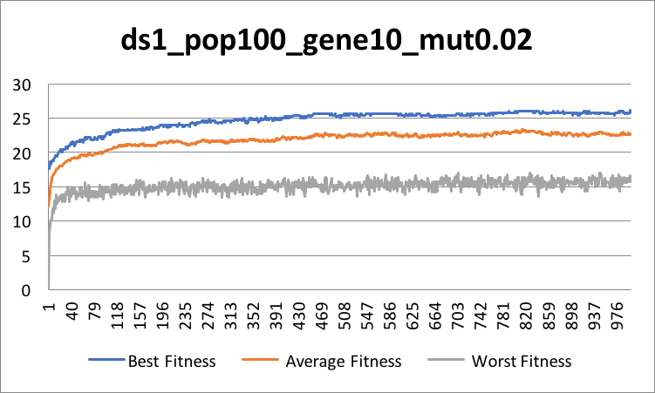
Figure 1 Initial Performance in Data Set 1

Figure 1 is the result from 1000 generations, with 100 population, 10 gene sizes and mutation rate 0.02. We can see the best fitness increase sharply in the first and then it stuck in local optima, around 25-26. Let’s try higher mutation rate.

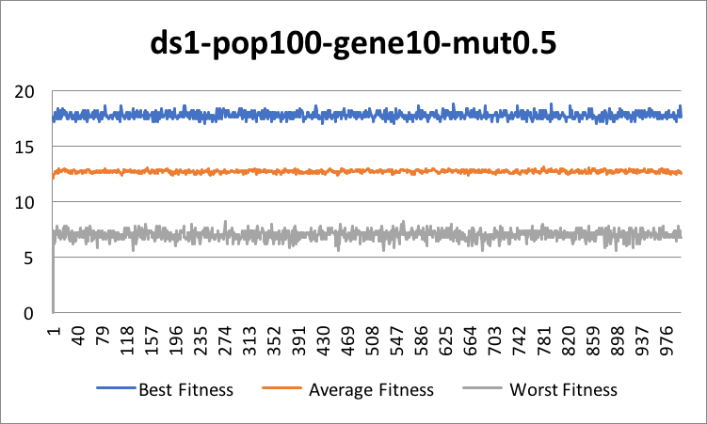
Figure 2 High Mutation Rate in Data Set 1

Figure 2 is the result of increased the mutation rate. 0.5 mutation rate means every two individuals, there is one being mutate. More mutation led to more new gene set being generate. Which for each generation half of it is like new individual, there are no evolutionary in it.

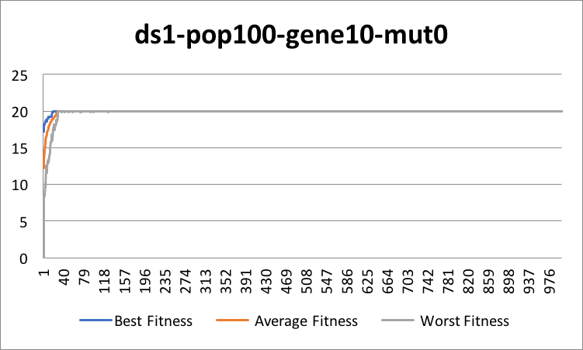
Figure 3 No Mutation in Data Set 1

Figure 3 shows the result of the no mutation. From the graph, the fitness has increase and then stuck at 20. This is because, no mutation, only crossover is done to generate new gene set, but after a time, the crossover can only generate the exist gene set. Therefore, it stuck in local optima.

For GA, mutation is an important process, without it data mining will never get the local optima.

3.2 Data Set 2
Data set 2 is similar with data set 1, it uses 64 rows of rule and the rule size is 7 instead. In data set 2 I will test the gene size and population size affect to the GA.

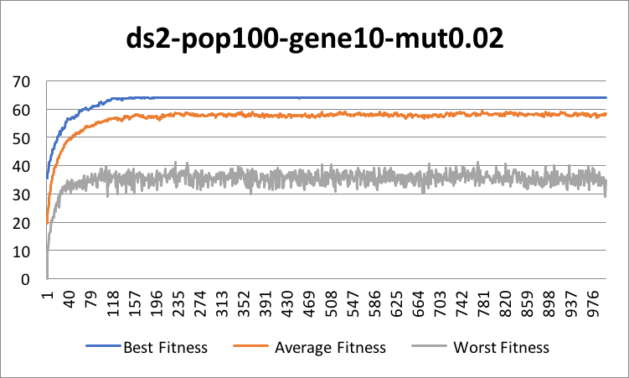
Figure 4 Initial Performance in Data Set 2

Figure 4 is the result from 1000 generations, with 100 population, 10 gene sizes and mutation rate 0.02. After 200 generations, it reaches the local optima 64, which all the rules have passed.

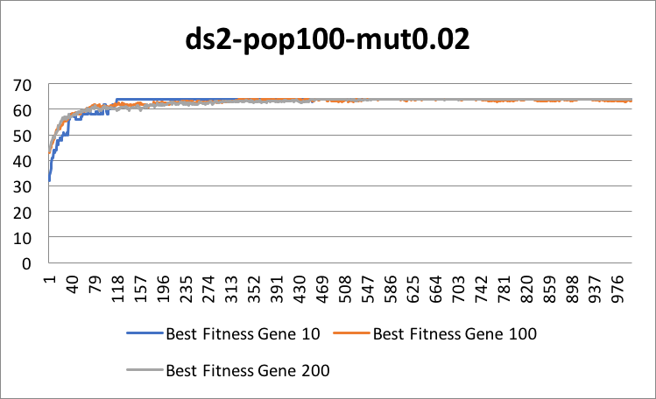
Figure 5 Different Genes Performance in Data Set 2

According to the figure 5, the gene size does affect to the GA depends on the size of the rule set. The time it reaches the local optima. Because more genes led to higher chance to get result without any generics. In this case we only have 64 rules and we give 200 genes to solve the rule.

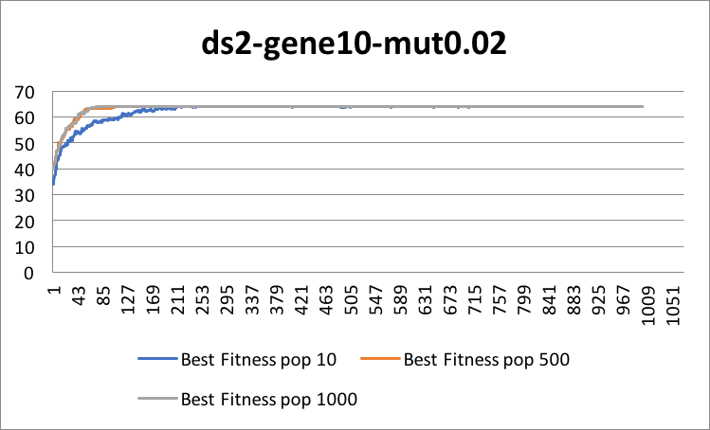
Figure 6 Different Population Performance in Data Set 2

Figure 6 shows the result in different population size. We can see high population get the local optimal faster than low population. It is because the more population means there are more diverse, which it has better chance to getting to the best. However, higher population will make the process time increase.

In conclusion population size and gene size will affect to the GA process time. Also, the error set of population size or gene size will make the algorithm further away from GA, it will become more like the brute force and we don’t want to use the brute force to solve the problem.

3.3 Data Set 3
Data set 3 is total different with 1 and 2, it provides the floating point rather than the binary number. In each rule set, it contains 6 floating point for condition and binary number for output. Each of the floating-point conditions will be encoded with a lower bound and an upper bound. The output is just encoded with binary number 1 and 0. The encoding at first will not completely match with the bound, but after the evolve more bounds should be match the dataset. Mutation of this is to mutate the bounds by a little bit, this is known as creep. After the mutation and crossover, we need to reorganize the bounds, to make sure that it is in the correct positions.

Also, the because of the data set 3 contains 2000 rows of the rules, and we want the schema that comes out to be as agile/useful as possible. We have split it into half, first half use to training and the second half use to testing. Using half of them in the testing can ensure that we are not overfitting. And regular checks (each 10th generation) against test set to ensure that we are still on target to prevent the error.

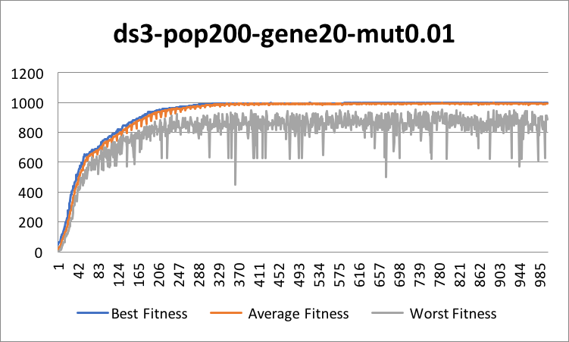
Figure 7 Initial Performance in Data Set 3

Figure 7 is the result of population size 200, gene size 20 and mutation rate 0.01 under 3000 generations. It is pretty much same with data set 1 and 2.

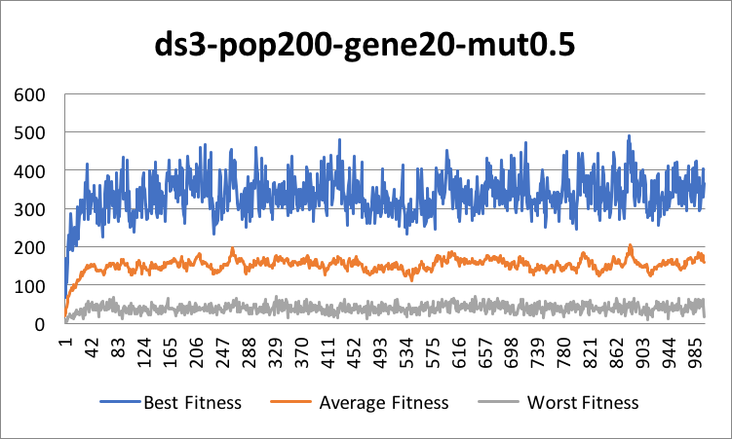
Figure 8 High Mutation Rate in Data Set 3

After the increase of the mutation in the data set 3, we can see from the figure 8, the fitness is bound frequently from 200 to 500. Compare to the Figure 2 in data set 1, high mutation rate affects the larger data set more.

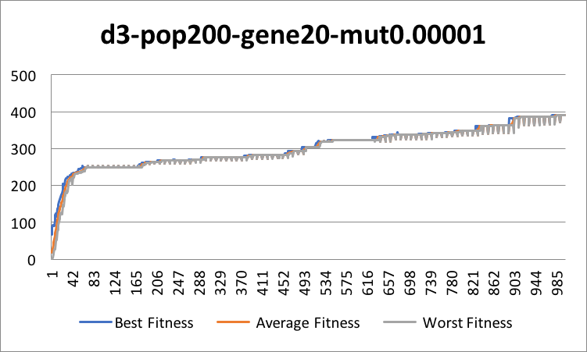
Figure 9 Low Mutation Rate in Data Set 3

Let’s test the low mutation rate. In figure 9, the mutation rate is decrease to 0.00001. Although the convergence makes it falling to the local optima rather than the global optimum, we can see the fitness is increase steadily, which after more generation, I am sure it will pass all the test.

From the test, we can see the change of mutation rate in large data set will change the result of the GA. Higher mutation rate will increase the chance to search new area in the search space, but it will stop the population converge toward to the optimal solution. Lower mutation rate will cause premature convergence to the result.

4 CONCLUSIONS
GA can use to solve the classification problems well. The traits of GA contain makes it become most popular searching method in the EA. The mutation and crossover make the more diversity on the population and avoid the stuck in the local optima. It is useful for on solve brute force search problems. However it is notorious for its long training time, by involve so many parameters.

REFERENCES
Srinivasa, K.G., Venugopal, K.R. and Patnaik, L.M. (2007) A self-adaptive migration model genetic algorithm for data mining applications. Information Sciences [online]. 177 (20), pp. 4295-4313 [Accessed 02 May 2007].

Khoo, L.P. and Zhai, L.Y. (2001) A prototype genetic algorithm-enhanced rough set-based rule induction system. Computers in Industry [online]. 46 (1), pp. 95-106. [Accessed 19 May 2001].

Kumar, S. and Rao, C.S.P. (2009) Application of ant colony, genetic algorithm and data mining-based techniques for scheduling. Robotics and Computer Integrated Manufacturing [online]. 25 (6), pp. 901-908. [Accessed 09 April 2009].

Hsu, P.L., Lai, R. and Chiu, C.C. (2003) The hybrid of association rule algorithms and genetic algorithms for tree induction: an example of predicting the student course performance. Expert Systems with Applications[online]. 25 (1), pp. 51-62. [Accessed July 2003].

Khalid, J. (2013) Selection Methods for Genetic Algorithms. International Journal of Emerging Sciences [online]. 3, pp. 333-344. [Accessed 01 December 2013].

Khalidanirban, M., Ujjwal, M., Sanghamitra, B. and Carlos Artemio, C.C. (2014) A Survey of Multiobjective Evolutionary Algorithms for Data Mining: Part I. IEEE Transactions on Evolutionary Computation [online]. 18 (1), pp. 4-19. [Accessed February 2014].

